THE ROLE OF MYTH IN RELIGION

UNDERSTANDING MYTH AS SACRED LITERATURE

Question 1

What do you think of when you hear the word ‘myth’? What has influenced this understanding?

Myths play a unique, foundational role in religions. They help answer the questions surrounding the most mysterious moments of human existence – birth, death and initiation into a higher level of group belonging. Most importantly, they are the sacred stories that explain the primordial (first, creation) even that gave human beings their place in the cosmos (the universe as it was understood at the time).

Myth does not pretend to be history; in fact, it is before history because it tells of the instant when the gods intervened to create the world and, especially, human beings. As such myth is the start of history. Its truth is the holy, sacred truth that reveals the most authentic meaning of life. Myth is not meant to explain in a scientific sense, but to present in a symbolic manner a reality too great to define exactly.

Question 2

Myth is religious truth rather than historical fact. Explain the difference.

Question 3

Define what is mean by cosmology.

The diagram below represents the Semitic (said to be the descendants of Noah’s son, Shem) cosmology. This outlook is linked to the myth of how the universe was created and the sense of order that resulted. It is similar to many ancient views – that the earth was flat, supported underneath and covered by a dome which provided pathways for the sun, moon and stars. Often good and evil gods fought for control of the cosmos.

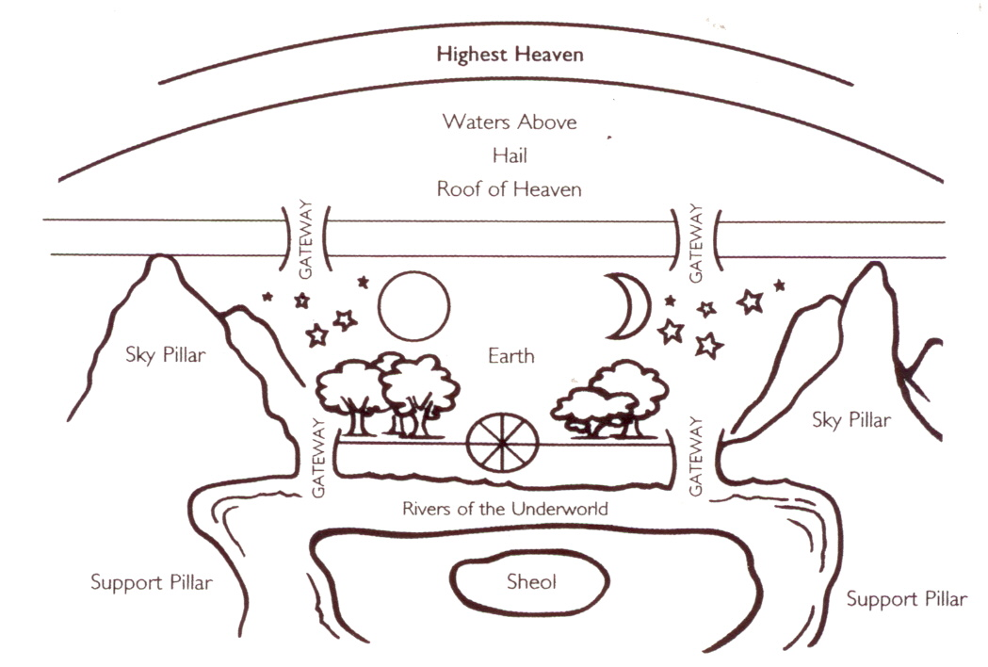

Question 4

Describe the environmental factors that would have influenced this ancient people’s understanding of cosmology.

Question 5

What indications of these factors can you see in the diagram?

Question 6
There is a difference between the things that are able the earth and the things that are below. Describe this difference. What might account for it?

