Shabbat Symbols & Foods
Shabbat is the period from twilight on Friday to nighfall on Saturday evening. It is the most precious time of the whole week in the Jewish calendar. Shabbat is a time for peace, harmony, tranquillity, community and spirituality that is unmatched on any other day.

Candlesticks
The candle is very significant in Jewish life. Fire is one of the basic elements of the world. It is frightening, as well as warm and inviting. In the Kabbalah (Jewish mysticism), the flame is said to symbolise God’s relation to the world and man.
Candles are lit on the Friday night leading into Shabbat (Sabbath) as part of Shalom Bayit (harmony in the home), and Oneg Shabbat (Sabbath joy). God “sanctified us by His commandments and commanded us to kindle the Sabbath light.” The candles should be in the room where the Friday night meal is eaten.
Our way of saying “Shabbat Shalom”, hello and welcome to Shabbat, is to light the candles. The woman of the house usually lights the candles, unless there is no woman present.
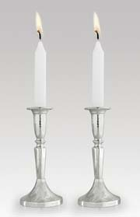
Candles can be lit up to one and a quarter hours before the commencement of Shabbat, but are usually lit 18 minutes before sunset. If need be, candles may be lit during the 18 minutes preceding the sunset.
At least two candles must be lit, to signify shamor (observance) and zachor (remembrance). The pair also symbolise the duality of all being: man and woman, body and soul, speech and silence, creation and revelation.
It is permissible and quite common to light more than two candles on Shabbat, in celebration of the light with which God blessed the seventh day during Creation. Some people light an additional candle for every member of the family. Once a certain amount of candles have been lit it is customary never to decrease that amount.
The procedure for candle-lighting is as follows: candles are lit at the appropriate time; the hands are then drawn around the candles towards the face between one and seven times to welcome the Shabbat Bride (Sabbath Queen), and to draw the light into oneself. The eyes are then covered with both hands, and the blessing is recited.
According to Halachah (Jewish law), a blessing is said before an act. In this instance the blessing of the candles initiates the Shabbat, therefore it is forbidden to light them after the blessing. To counteract this, the eyes are covered so that the light is seen as new after the blessing has been said.
On Saturday night, Havdalah is made with a Havdalah candle, a cup of wine and fragrant spices, to farewell the Sabbath and begin the new week.
For Jews, the candle will continue to symbolise the spirit of God, the light of the Torah, the conclusion of the Sabbath, and the memory of departed souls.

Challah
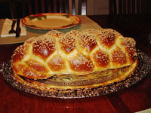
Challah is the traditional plaited bread especially baked for Shabbat and other holidays. It is customary to home bake challah to emphasise the feeling of unity, warmth and love that the Sabbath and other holidays represent.
Challah means ‘dough’, in particular the separated portion of dough from each batch of bread.
It is a mitzvah (commandment) as prescribed in the Torah, to separate the head of the challah, which is to be given to the priests (Kohanim). This mitzvah has been fulfilled since the destruction of the Temple, by removing a portion from the head of the braided dough before it is baked. The piece is then burnt in the oven to symbolise and commemorate sacrifice as well as the destruction of the Temple.
It is only necessary to separate breads made from barley, maize, spelt, wheat or oats. Challah was once considered a rich man’s bread, as it contained grain. It was specifically eaten on Shabbat and holidays as an indulgence and this tradition remains.
A piece of challah for the ritual burning can be removed after baking if it has not been done prior. A special blessing is recited upon this separation: “Blessed are You, Lord our God, King of the Universe, who has sanctified us with His commandments and commanded us to separate.”
On Friday Night two challot (the plural of challah) are present on the dinner table. This commemorates the double portion of manna that was received from God on Fridays by the people of Israel in the desert. This provided the people in the desert with manna for Shabbat. Some people sprinkle sesame or poppy seeds over the challah before baking to further symbolise this manna.
A blessing is recited before the breaking and eating of the bread. It is common practice to refrain from cutting the bread with a knife, which is likened to the weapons of war used to profane the altar, as decreed in Exodus 20:22. This custom also signifies Isaiah’s prophecy in Isaiah 2:4: “And they shall beat their swords into plowshares…” Thus the challah is broken up and divided by hand.
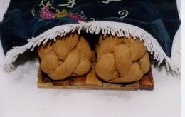
Challah is traditionally covered by a challah cloth prior to the saying of the blessing over the bread. Here the challah cloth is partially removed to allow the two challahs underneath to be seen. Note that they rest on a special, decorative challah (bread) board.
After the bread has been blessed it should be salted, in recognition of the rituals of the Temple sacrifices, and a reflection of Genesis 3:19: “By the sweat of your brow shall you get bread to eat”.
It is customary to leave the broken bread on a communal plate, or for a piece to be put on every individual plate instead of handing it to people, to stress that we do not receive our bread from man. This further reminds us of God’s presence and provision.
Before the challah is blessed, and during the blessing for the wine, the bread is kept covered by a cloth. This is to shield its ‘sensitive feelings’, teaching us that we must respect inanimate objects as well as those that live.
Challah is much more than simply plaited bread, as it is eaten on Shabbat and holidays. It is highly symbolic, reminding us of the significance of even the smallest things, and also that there is reason for everything we do.

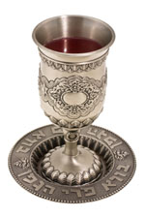
Wine and kiddush cup
Wine is regarded as particularly sacred and has its own bracha (blessing). Wine sanctifies the Sabbath at its inception (kiddush) and its conclusion (havdalah). The English word 'wine' may derive from the Hebrew yayin.
The kiddush cup is a special goblet set aside for the blessing of the wine. If possible, it should be made from silver. The kiddush wine should lull you into a state of Shabbat serenity. It symbolises joy and cheer, and therefore it is fitting to declare the sanctity of the Sabbath over the cup of wine.

Shabbat attire
On Shabbat we put on our best clothes, dressing as if for an important occasion. This reflects the mood of Shabbat, that it is different and special and worthy of respect.

The Shabbat table
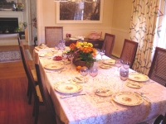
The Shabbat table is seen as an altar and should be covered with a special white cloth, and set with the best china and silver to honour the Shabbat Queen. The white cloth is said to represent the white manna, a double portion of which was gathered on Friday to last for Shabbat.
Shabbat food should be the tastiest and best; it is said that Shabbat adds a special seasoning to your food. Symbolic Shabbat foods include gefilte fish, chicken soup, kugel, challot and cholent.
The eating of fish on Shabbat is interpreted as a symbol of the blessing that the children of Israel would multiply like the stars in the heavens and the sand of the seas. The kugel (potato bake) is supposed to remind us of the manna, which was made up of globules. Cholent (stew) is made to enable the Jews to eat warm food on Shabbat, as it is put in the oven late Friday afternoon and remains there, sealed, until Shabbat lunch.
Zemirot
Zemirot (Sabbath table hymns) provide the distinguishing characteristics of the Shabbat meal. They are unique because of their unique blending of the holy and the secular, the serious and the playful. As the zemirot are sung, we forget our weekday worries, burdens and sorrows and experience complete mental and physical relaxation. Sometimes, modern songs both in Hebrew and the vernacular supplement the medieval zemirot.

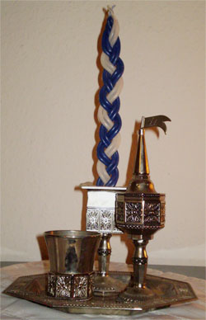
Havdalah set
A typcial havdalah set consisting of wine cup, candle holder and spice box
Havdalah is the short ceremony that farewells the Shabbat and ushers in a new week. A special twisted multi-wick candle is lit, or, failing this, two lit candles may be used and their flames put together. This reminds us of a midrash (rabbinic tradition) that G-d showed Adam and Eve how to make fire at the conclusion of the first Sabbath and shortly before they were expelled from the Garden of Eden. Many people have the custom of using a candle with six braids which represent the six secular days of the week which culminate in the spiritual highlight of Shabbat. As we look at the havdalah candle, we look at our fingers to make use of the light, and thus not render the benediction over the light in vain.
The sweet smelling spices used for Havdalah symbolise a spiritual feast for the extra soul (neshama yetairah) which leaves our bodies at the conclusion of Shabbat. The spices are a last taste of paradise.
Wine is also blessed and drunk, and used to extinguish the havdalah candle. Just as it is customary to begin Shabbat with a cup of wine, so do we end it with wine.
http://bje.org.au/learning/judaism/holydays/shabbat/symbols_foods.html

