Religion and Culture
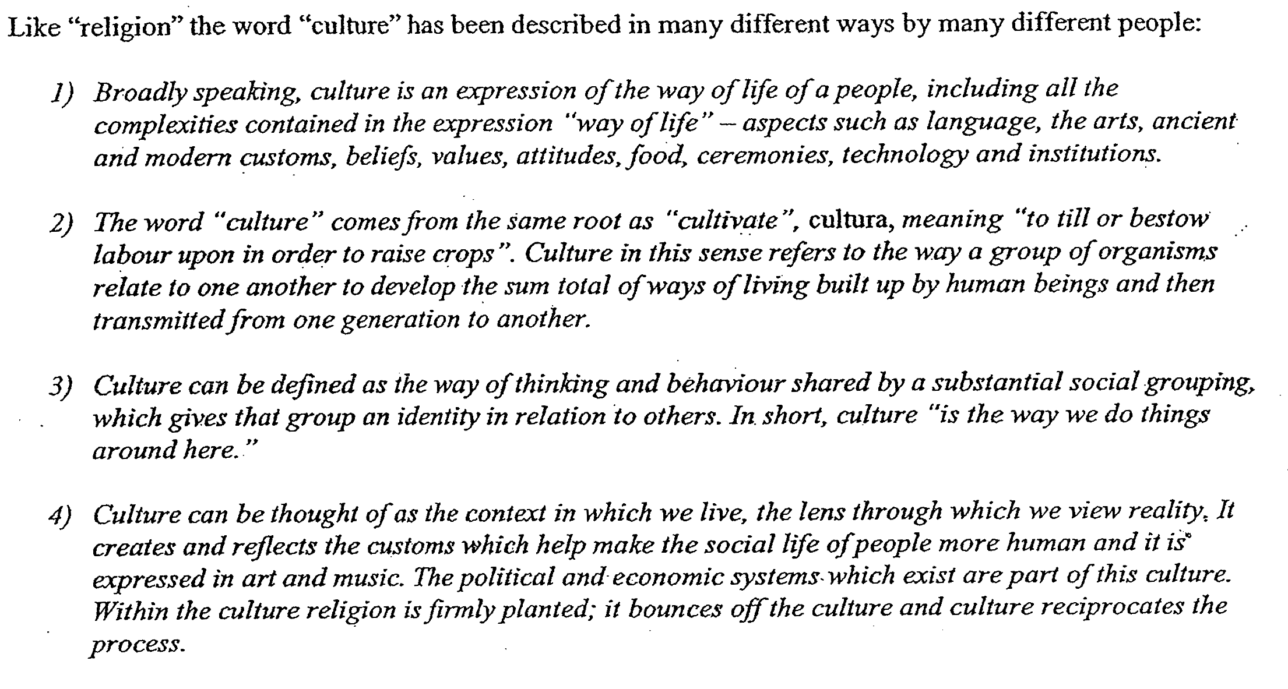
- How would you define culture?

- How would you describe the relationship between religion and culture?

- Each religious tradition exists within and responds to its own culture. For some religion and culture are synonymous?

- Religious traditions have shaped culture in important ways. Eg.

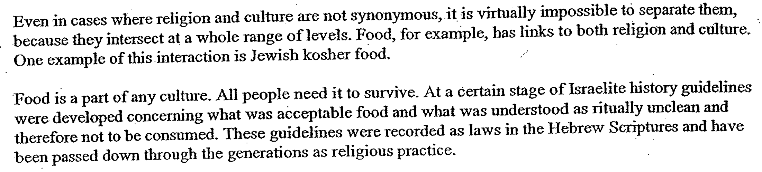

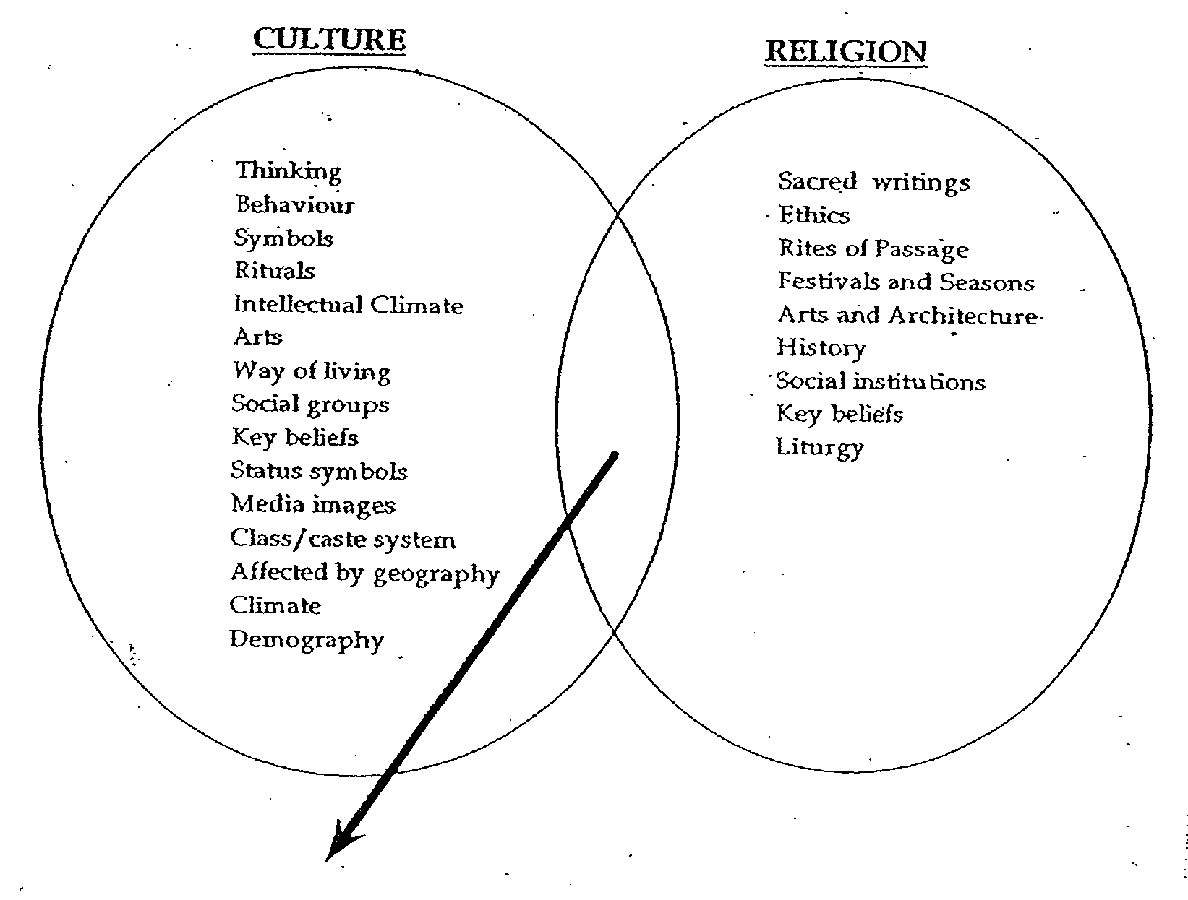
Culture and religion intersect on the issue of food.
Eg 1 – Kosher food for Jews
Abstinence for Christians
Eg 2 - Different foods for different festivals

5. Suggest three other issues on which culture and religion intersect and explain how they did so:
Example 1: | Example 2: | Example 3:
6. Sometimes it is easy to confuse religion and culture and this confusion persists to the extent that in some cases even adherents to the faith cannot distinguish them. Examples of these include:

- Woman in Islam b) ???????
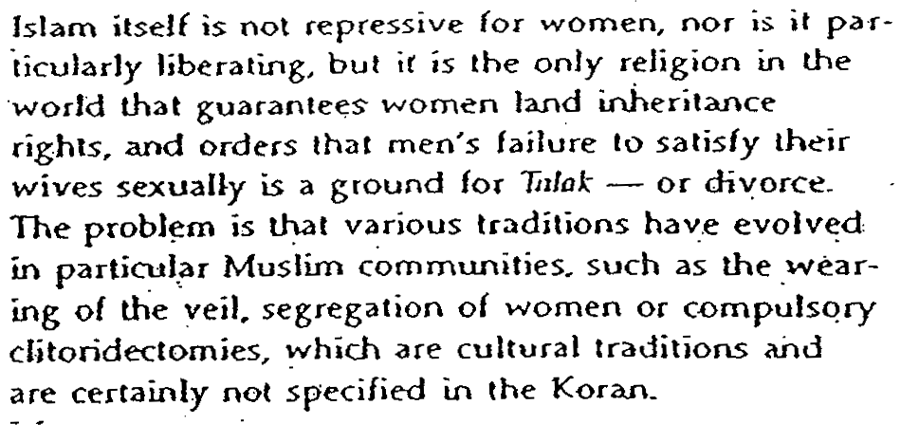
7. List other examples of the contribution of religion to the following areas :

Art / music / architecture / food /dress

8. Describe the ways which religion can be both a source of cultural cohesion and transformation in society. Support this with examples from the past and the world today.

9. Describe and explain the contribution of religion to
A)

B) Society and culture

