Section I
Part A – Religion and Belief Systems in Australia post-1945
15 marks

Allow about 25 minutes for this part
Attempt Questions 1–11

Use the multiple choice answer sheet for Questions 1–10.

- On what project did Sir Ronald Wilson and Mr Michael Dodson work together?

  - They were barristers in the Royal Commission into Black Deaths in Custody.
  - They were authors of Bringing Them Home, a report on the Stolen Generations.
  - They were indigenous Australians working for the National Human Rights and Equal Opportunity Commission.
  - They were judges in the court that made the Mabo decision.

- In 2006, what could be said about the number of Roman Catholic adherents in Australia?

  - It was smaller than the number of Anglican adherents and Protestant adherents combined in Australia.
  - It was smaller than the number of adherents of all non-Christian religious traditions in Australia.
  - It was smaller than the number of adherents in all the Christian Orthodox denominations in Australia.
  - It was smaller than the number of Catholic Australians who were non-Roman Catholics.

- Of what did kinship groups in Aboriginal societies consist?

  - Parents, the siblings of the parents, and the descendants of the parents only.
  - Groups of 300 to 500 adults and children.
  - Members of any group that could be supported by a nomadic lifestyle.
  - Groups of 300 to 500 adults and children and their environment.

- What did the 2006 Australian Census reveal about numbers of Pentecostals compared to other Christian denominations in the past decade?

  - They had very high proportional growth in the past decade but were still small in overall numbers.
  - They had very high proportional growth in the past decade and would probably become the largest Protestant denomination in the next decade.
  - They had very low proportional growth in the past decade and were still small in overall numbers.
  - They had very low proportional growth in the past decade but were still large in overall numbers.

- Which of the following was a recommendation of the National Inquiry into the compulsory separation of indigenous children from their families and communities?

  - If land rights had been continually exercised by Indigenous people and had not been alienated by statute, then that land should legally belong to them.
  - Native title rights and pastoral rights should be able to coexist on land that has been leased from the government.
  - People from all religious traditions should support the Howard Ten Point Plan.
  - A national ‘Sorry Day’ should be held each year that would be given the same recognition as Anzac Day.

- What is ecumenism?

  - It is when different Christian denominations co-operate.
  - It is when different religious traditions co-operate.
  - It is when a person changes from one denomination to a different denomination.
  - It is when there is rigid support of one’s own denomination and hostility towards other denominations.

- What is a skin name?

  - Any name given to a newborn Aboriginal baby.
  - An additional name given to an Aboriginal person at birth and which indicates their birth order in the family.
  - A name that belongs to an Aboriginal person from birth and which indicates that person’s relationship to others.
  - A name that shows an Aboriginal person’s kinship but that is not used after marriage.

- Which of the following events most influenced Australia’s receiving of an increased number of refugees and migrants from Asia after 1975?

  - The ending of World War II.
  - The ending of migration from the United Kingdom.
  - The ending of the Vietnam War.
  - The ending of the Cold War.

Questions 9 and 10 refer to Source A, the painting My Country’s Corroboree by Spider Snell, and quotation below.

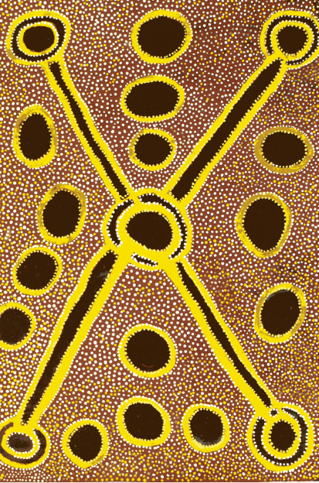
Source: My Country’s Corroboree, by Spider Snell, Mankaja Arts Centre, Fitzroy Crossing, Western Australia.

Of his painting My Country’s Corroboree, above, Spider Snell said:
‘This is my country. I own the corroboree from the desert for this place. It is a big place
for Dreaming ceremonies. Two big groups of people travelled to this place for the ceremony. They met at the soakwater* in the centre. They split up again and went on to two other places.’

*A soakwater is a shallow hole or depression in the ground where rainwater collects.

- In the context of his statement above, what does Spider Snell mean by ‘my country’?

  - Australia, the nation of which he is a citizen.
  - An area of traditional land with which he has spiritual links.
  - The rural district he lives in as opposed to a town or a city.
  - The unique qualities and culture of the Australian people.

- In the context of his statement above, what does Spider Snell mean by ‘Dreaming’?

  - A succession of images or ideas present in the mind during sleep.
  - A view of how the world was created and the rituals that sustain it.
  - A fantasy that is voluntarily thought about while people are awake.
  - Something that is imagined in sleep or in a vision.
Marking guidelines

Section I
Part A – Religion and Belief Systems in Australia post-1945
1 | B
2 | A
3 | D
4 | A
5 | D
6 | A
7 | C
8 | C
9 | B
10 | B

