CHARACTERISTICS COMMON TO ALL PREHISTORIC RELIGIONS

From what is now known about prehistoric human societies, religion played a very important role in every early society and affected the style of life, the structure of the society, and the relationship of members of the society with one another.

In spite of the fact that these early societies were isolated from each other, having little, if any contact with each other (and often concealing their beliefs and practices from any with which they came in contact), all prejistoric religions and certain characteristics are the following:

- Belief in spirit-forces or invisible powers

All prehistoric people believed that everything was controlled by unseen nonmaterial or spiritual forces or powers often arranged in hierarchies of power and divided into friendly or hostile powers. There were spirits controlling every conceivable aspect and experience of life: they made trees grow, clouds move, fires burn, the earth quake, the thunder clap, the lightning flash, the waters move, people sicken, the crops grow or fail, the hunt succeed or not, the tribe prosper, and so forth. The good or evil experienced by every person or tribe was the direct result of the work of these invisible forces or powers, which acted not only on earth but in the sky and under the earth as well.

- Close ties to a particular area or locality

Prehistoric religions were not universal. They did not try to be transcultural. They were closely tied to the territory in which the people lived, to the values perceived as necessary for survival, and to the mores of the close knit society which practiced them.

- A prescientific world view

The world of prehistoric people was circumscribed by where the people lived. They had no notion of a much larger world where things other than those with which they were familiar existed. Their world was governed by mystical forces that were capricious and unpredictable. They did not conceive of a world governed by predictable, natural forces.

- Concern with survival

Prehistoric religions primarily focused on ensuring the success of those practical matters which affected the survival of the tribe. Their rituals centred on the hunt, the growth of crops, success against enemies and the birth of healthy children.

- Manipulation and coercion of the world of the spirits

Actions directly associated with religion – as distinct from merely cultural practices – became a part of all early human societies. These “acts of worship”, or liturgies, were directed to particular gods or spirits of unknown and uncertain power who affected people’s lives and their life situations. The actions were designed to ward off evil spirits and to call on friendly spirits for assistance.

These actions were designed to force the gods or spirits to act in accordance with the wishes or desires of individuals or tribes. They were performed, for the most part, by some individual in the tribe who seemed to possess special powers or influence over the spirit or force, or one who had a special relationship with the spirits or forces. They were participated in by individuals or members of the tribe who performed particular rituals of actions, sang particular incantations, or recited particular words at the direction of the leader or witch doctor. Such ritualistic actions, designed to force the gods or spirits to action, are called magic – the art of producing a desired effect through the use of various techniques, incantations, or potions designed to control the spiritual forces on powers controlling the universe.

- Concern about death

All prehistoric people believed that human spirit lived in another world after death – the result of the relationship they saw between sleep and dreams and death. They developed elaborate burial ceremonies designed to make a dead person’s passage to and existence in that world happy and prosperous. Many early tribes, believing that the spirits of the dead might return to haunt the living, developed magical actions or burial ceremonies to prevent such spirits from returning to disturb the tribe, or rituals designed to confuse the spirit of the dead person so that it could not find its way back to the tribe. Other rituals were designed to honor the dead and preserve the memory of heroes, kings or leaders. In almost all cases, these acts were special religious acts – ways of dealing with the mystery of death.

- Ethical System

Every prehistoric society had rules governing their way of life according to the particular needs of the tribe and their religious beliefs. Their moral codes included laws designed to protect the life of the tribe, such as laws prohibiting murder, adultery, stealing, lying, and so forth, and taboos and required actions based on religious beliefs.

Taboos, or positively forbidden actions, were the most powerful of the determining factors affecting a person’s or a tribe’s way of acting. They were always associated with the mysterious, or sacred, or spiritual, or totem forces affecting the life of the individual or tribe, and were forbidden because they were thought to automatically produce evil. A person who performed such a taboo action was required to undergo tribal purification, a system designed to ward off the evil effects of the action. Taboos and ritual purification were serious business; they were not merely superstitions as such. They were deeply associated with the religious beliefs of the tribe, and were revered and observed as sacred obligations to insure the survival of the tribe.

- Theology

All early societies developed a system of explanations for their religious beliefs and practices. These explanations were primitive according to our understanding of the world around us, but they were explanations that made sense to those who accepted them, and laid the foundation for later theological systems with which we may be familiar.

- Scripture

Though no records of prehistoric writing have been found, early religions in their later stages did have a body of sacred writing that was generally accepted as the sacred word or, at least, the will of the gods. Such writings originated in the word-of-mouth stories and poetry which preceded them and included the myths, explanations, words, songs, incantations, rituals, moral codes and general theology of the tribe. They intact and formed the fabric of beliefs and practices of the primitive tribe.⁴

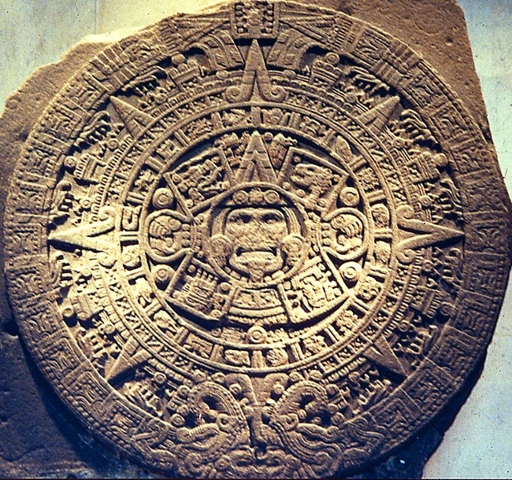
- Prophecy

There is present, in almost all early religious societies and certainly in all known early religions, an aspect of “prophetic witness”. By this is meant the presence of a person, particularly gifted, certainly charismatic, who, having experienced some extraordinary religious experience in himself or herself, exerts through words and actions, a profound and rather lasting effect on the religious life of the society which the person addresses.⁵

- Sacrifice

Gifts signify a relationship between the giver and the receiver. Archaeological discoveries reveal that in early societies, gifts were offered to the powers, forces, spirits or totems of the tribes were offered int he form of food, items of tribal value, or sacrificed animals. When the sacrifice was tribal, the slain animal was divided and parts were offered to the power, force, spirit or totem and the rest was eaten by the tribal members to signify their participation in the offering and their oneness with the spirit, force, power or totem.

- Designated places of worship

Archaeologists have discovered that in all early societies special places, areas, caves, rooms or structures were set aside for religious ceremonies. Whether it be in the caves of Europe, the excavations in Africa, or the digs of the Middle East, the pattern is the same: people have been preoccupied with religious concerns in a very special way. They set aside certain places and things to express their beliefs in words and actions to show their relationship to whatever God was for them.

It is significant that these features are common to nearly all known early religions, even when the communities were isolated from others by oceans, mountains, impassable waters, dense forests, or their own fears of the unknown. This suggests that early religions have common features, not because of an exchange of ideas with people in other parts of the world, but because religion fulfils a basic need of human nature itself.

